

American International University-Bangladesh (AIUB)

**Software Project 1**

**Charity Management System**

**Submitted By**

|  |  |
| --- | --- |
| 17-34625-2 | Sanzida Afrose Rikta |
| 18-36179-1 | Mustafizur Rahman |
| 18-36342-1 | Shameem Shahriar |
| 18-37675-1 | Rahat Maksud Pranto |

Department of Computer Science

Faculty of Science and Technology

American International University Bangladesh

August, 2021

|  |
| --- |
| **Declaration** |

We declare that this project is our original work. No part of this has been submitted elsewhere partially or fully for the award of any other degree. Any material reproduced in this project has been properly acknowledge.

We declare that this project does not contain any content that discloses the secret of any organization or related parties. American International University-Bangladesh (AIUB) will not be held liable for any such activity, as for the project is presented as our original work.





|  |  |
| --- | --- |
| _______________________________  **Sanzida Afrose Rikta**  17-34625-2  Computer Science | _______________________________  **Mustafizur Rahman**  18-36179-1  Computer Science |
|  |  |
| _______________________________  **Shameem Shahriar**  18-36342-1  Computer Science | _______________________________  **Rahat Maksud Pranto**  18-37675-1  Computer Science |

|  |
| --- |
| **Approval** |

The project titled “**Charity Management System**” has been submitted to the following respected members of the board of examiners of the department of computer science in partial fulfillment of the requirements for the degree of Bachelor of Science in Computer Science on (date of defense) and has been accepted as satisfactory.

|  |  |
| --- | --- |
| _______________________________  **M. Mahmudul Hasan**  Assistant Professor and Supervisor  Department of Computer Science  American International University-Bangladesh | _______________________________  **Raihan Uddin Ahmed**  Assistant Professor and External  Department of Computer Science  American International University-Bangladesh |
| _______________________________  **Dr. Mahbub Chowdhury Mishu** Head (Undergraduate Program) Department of Computer Science American International University-Bangladesh | _______________________________  **Professor Dr. Tafazzal Hossain** Dean Faculty of Science and Technology American International University-Bangladesh |
| _______________________________  **Dr. Carmen Z. Lamagna**  Vice Chancellor  American International University-Bangladesh | |

|  |
| --- |
| **Acknowledgement** |

This Project is our cordial effort and our supervisor’s initiative and constant motivation. But first of all, we would like to be grateful to the Almighty Allah, who gives us the effort to work on this project for the last one semester. Especially thanks go to our honorable supervisor M. Mahmudul Hasan faculty member, American International University-Bangladesh [AIUB] for this enormous support, inspiration, and helpful criticism. His excellent supervision and constant support make this project possible. We are very grateful to him for giving us the opportunity to work with him. We also convey our thanks to our honorable Vice Chancellor, Dr. Carmen Z. Lamagna, our Dean, Prof. Dr. Tafazzal Hossain, our Associate Dean, Mashiour Rahman, our Director, Dr. Dip Nandi, and our Head of Department, Dr. Mahbub Chowdhury Mishu for their constant motivation and support.

Last but not least we thank our respectable parents for educating us with aspect from both arts and sciences, for their unconditional support and encouragement to pursue out interests, even when interests went out of boundary.

**TABLE OF CONTENTS**

**Project Summary** 6

**Keywords** 6

**CHAPTER 1: INTRODUCTION** 7

**1.1** **Charity Management System** 7

**1.2** **Project Background/Problem Analysis** 8

**1.3** **Research/Project Motivation and Objective** 9

**1.4** **Literature Review of Existing studies** 10

**CHAPTER 2: RESEARCH METHODOLOGY** 12

**2.1** **Conceptual Framework** 12

**2.2** **Data Collection Method** 13

**2.3** **Ethical Issue** 17

**CHAPTER 3: PROJECT PLAN** 18

**3.1 Project Effort Estimation** 18

**3.2** **Project Planning** 20

**3.3** **Uncertainties and Risk Analysis** 23

**3.4** **Project Execution** 23

**CHAPTER 4: RESULTS AND ANALYSIS** 25

**4.1** **Solution Description** 25

**4.1.1 Functional Requirements** 25

**4.1.2 Non-Functional Requirements** 28

**4.1.3 Design Specification (UML Diagrams)** 30

**4.1.3 UI/UX Design** 36

**4.2 Impact on Environment:** 39

**4.3 Lifecycle Analysis** 41

**4.4 Solution Verification** 43

**CONCLUSION** 48

**REFERENCE** 49

**APPENDIX** 50

# **Project Summary**

Charity is an act of kindness, where a person who has financially more than enough of what he or she needs contributes a part of his or her surplus income for the fulfilment of the needs of those who are less capable. The world is facing its worst time due to Covid-19. Government has declared lockdown, as a result the economic condition is getting worst day by day and people are becoming jobless. This is be most suitable time for the charities to stand by those helpless people. The majority of Charities have experienced difficulties in getting funds or other required things. Getting donor is a very hard task, and sometime dealing with some donor’s conditions can be a big challenge for Charities to fulfil it. This project work generally summarizes the activities carried out in the design and implementation of the Web-based charity management system. This charity management is a non-profit organizational system in which non-governmental organisations and donors can come in and request and donate funds and materials such as cloths, hospital equipment, etc. This system has two modules namely, Admin and Donor. Admin can login using credentials and manage the request raised by needy people by approving or rejecting it. Approval will be done after verifying the applicant’s documents uploaded by the applicant. The project's architecture was then built to depict the achievement of these goals using UML diagrams and an Entity Relationship diagram. The Scrum technique was utilized for the design of this research throughout the implementation phase. Many additional platforms exist, according to the literature studied, but they all have limitations. As a result, it is critical to investigate other resources that are both widely available and provide a better mix and improvement to help charities across the world. Anyone will agree with that this current project will no doubt boost the performance of the charity management firm as different services and operations are embedded on this project. This project will be able to supply solutions to charity management firm’s main issues by first enabling individuals to donate online instead of calling, which is seen to be beneficial for both Donors and Charities. Also, donors can also read about the Charities history and the variety of services offered and the helps they gave out all on the web. Secondly, the project will be an easier way to publicizes the firm by simply being published on the web. By the end of this project, The Charity Organization that will adopt this web approach will hopefully be able to keep track of appointment records, cutting down the number of phone calls received and finally help achieve the desired number of donors. Again, the aim of this project is to encourage the Charity Management system to rely mainly on technology to publicize their firm and communicate with donor/individuals. Finally, the implementation of this project will benefit the Bangladesh society and the world as a whole. Also, a concise report on the implementation of each phase of this project will be developed and further development will be available.

# **Keywords**

Charity Management System, Non-Government Organization (NGO), System Development,

Donation, Charities, Agile Development, Application.

# **CHAPTER 1: INTRODUCTION**

# **Charity Management System**

Charity is any kind of generous action towards those in need. It can be money; products and it can be given directly or indirectly through any system. Charity is for those people who are devastated and feeble or harmed, who are unable to earn money to buy food or necessities due to their situation. Also, any kind of generous activity like visiting people who are unable to go outside their house because of their difficult situation, teaching the homeless, helping social developments can be noted as charity.

Charity in human culture has a long history. In the past, numerous charitable associations have created ideals which are still being followed but in a different way.  People used to follow these ideals and donate directly to those in need. Associations evolved to execute the endeavors of assisting the people in need and these associations called charities, supply a big scale of charitable giving nowadays, regarding financial merit. These involve orphanages, religious associations devoted to keeping the people in need safe and providing them their needs, hospitals, firms that often visit the homebound people, and more. Such associations give permission to those whose time and tendency does not impact themselves directly care for the people in need to allow others to do so, both by giving wages for the work and maintaining them while they carry out labor. Sometimes associations can also try to differentiate the real people in need from those who claim charity with foul motive [1].

From a religious perspective, charity has been told in every religion. In Islam there are two types of charity. They are called Zakat and Sadaqa. There are total 5 pillars on which Islam is based and Zakat is one of them. The process of Zakat is simple, 2.5 percent of the saving is mandatory to be given as Zakat per Islamic year. Similar charity has been called Dana or Daana in Hinduism, Buddhism and Jainism. It is the righteousness of kindness or giving. Dana has been mentioned in holy texts of Rigveda.

As our society is becoming modern and the lives of people getting busier day by day, it has become hard to do charity directly. But with the blessing of the internet doing charity has become easier because in recent times everything in the world is done online. Based on online charity, the overall donation/charity has grown drastically. According to online statistics, about 50 percent UK residents and about 84 percent Canadians donate money to charities. About 31 percent of people in the world donate to other countries than their own countries. The countries listed in the top 5 that receive money from other countries are India (4%), USA (17%), Israel (8%), Syria (5%) and Canada (7%). About 41 percent of people who donate money to these countries have responded that they donate money because of natural disasters those countries face. Half of donors in Asia like to do online charity. About 51 percent of Asian donors like to donate via online [2].

This charity management system project aims to find out and solve problems that people are having while doing charity via online. Consequently, the primary contributions of this project are as follows: (a) empirically investigate charity done via online in Bangladesh, (b) analyze and understand the problems and try to solve those problems. Besides, this project will also assist the foreign donors to donate to Bangladesh and Bangladeshi donors to donate to foreign countries.

This software project is organized as follows, in section 1.2 to 1.4 the background/problem analysis, project objectives and literature review of existing projects are presented, chapter 2 detail the research methodology for conducting this project. Project plan is presented in chapter 3. Finally, in chapter 4 the results and analysis of this project are presented.

References:

[1] Wikipedia. (2021, June 3). Retrieved from Wikipedia: <https://en.wikipedia.org/wiki/Charity_(practice)?fbclid=IwAR32ZWlocI5rsGThOmLXdVv2BDjjzpI5jEYYf0C4Ln0laZvJ7TaOiXQVMwY>

[2] Balancing Everything. (2021, June 3). Retrieved from <https://balancingeverything.com/charitable-giving> statitics/?fbclid=IwAR2nND3t6jgVgIopXLnebUldoRuqHQUVUh14BEXMSozBKL1Dmr7elCMnKE

# **Project Background/Problem Analysis**

As the famous saying goes, Givers won't ever need. Everybody needs to prevail throughout everyday life, most people who wish to find out about the cause giving administrations or industry and advantages need to visit one of the foundations associations closest to them or approach the individual phone to book an arrangement. Lately, the cause association has been developing at an extraordinary speed with its exceptional difficulties actually like some other industry. The fundamental issues looked by good cause associations as distinguished are as per the following:

* Contributors physically book arrangements, and the proprietors of these organizations record similar arrangements in the journal and forget the majority of them because of the great number of benefactors.
* Overpowering calls from contributors who just wish to find out about the administrations and not really book an arrangement.
* Although most of these charity organizations have attracted a good number of donors and NGOs, they are yet to achieve the desired number of individuals/donors as originally planned.

Due to the effect of COVID-19 the economic situation of the world is becoming poor day by day. Our economic situation is also very poor. After the declaration of lockdown all work places became closed. For that reason, those people who are day laborer lost their earning, those who belong to a middle-class family lost their jobs because many factories and companies get closed. Many companies refused to give salaries and started firing their employees. Though the govt gave help but it became beneficial only for the poor and day laborers. Many middle-class people cannot ask for help due to self-respect. They neither can ask for help nor can ask money in the street. At this time, many people and organizations came out to help the helpless people. Huge amount of money and food were donated to the helpless people but due to lack of proper distribution all the donations were not given to actual needy people. Besides this, there are a big number of children and helpless women in our country. Every year disasters occurs and make a huge destruction, as a result many people become homeless and helpless.

Something other is that we by and by know givers. We made research in this part and found many people working with a couple of givers. We found a group of people who have been getting entire bunches of gifts from benefactors like the BASMAH foundation is a US-based Charity Organization and they worked with it on two unique events first it brought food and dress materials to the inside dislodged people (IDP). During this visit they went round the IDP camp and saw a many individuals going through difficulty so they chose to take their photos and afterward he acquainted with its associates back in the US and they truly assisted with entire bunches of things and financing. During that walk, they met some disabled person people being pushed in Carts, so they took pictures of them and sent it to its colleagues. In this way, after certain months BASMAH establishment returned with wheelchairs, apparel, shoes, clinic gear and so on and the second giver they worked with was APON Foundation likewise, a US-based Agency claimed by Mr. Saif Rashid and really welcomed him to come and help the inside uprooted people (IDP) thus he gave $50,000 US dollars and some food materials, during his visit they likewise circumvented the camp and took an investigation of individuals around there and that got them to tackle issues like reclaiming kids that are out of school back to the best schools. During that time the DC heard the work they have been doing and praised them and requested that they proceed with the sky is limit and assisted them with the venture they were on and gave every one of the kids they chose in that IDP camps scholarships.

Thus, these are the reasons we picked this our venture since it's the first of its sort and we are focusing to extend and bringing more givers and NGOs together. This entire inspiration is about how I had the opportunity to connect givers and Individuals not NGOs and this is likewise what the cause the executive’s framework will really do.

# **Research/Project Motivation and Objective**

The reason/motivation why we started this project is because of the lack of Charity management organizations in Bangladesh, that is locally meant for Bangladeshis, that will reach out to those individuals that really need help from donors and NGOs or even those NGOs that need help from other donors that are willing to help our dear country and don’t know how to go about it or they might even tend to give it to people to distribute and end up not reaching those that the funding was even donated for.

Therefore, the aim of this project is to mainly resolve these problems by designing a web-based system to the charity management systems in the charity organizations that includes the following features by just one click on a link:

* A brief introduction to the charity organization and a small profile about the organization owners and volunteers.
* A page that includes all the services offered by the organization.
* Contact details of the volunteers.
* “Book an appointment now” link by which anyone can meet the top-level officials to discuss any issue.
* Brief introduction to the charity funding.
* Mobile app that will enable donor to view all these services at them comfort zones and book appointments.
* The donors should be able to carry out due diligence of the organizations via the web.
* Design and integrate an automated system to improve the services and decreased the time spent calls and searching for services offered in the donation.
* Configure a gateway system for online payment to enable individual’s ease of payment from their mobile devices.
* Design and implement users register page, login, and online appointment booking.

# **Literature Review of Existing studies**

“Good ideas and values are the foundation of a strong charity.” According to Joe Saxton, charities should borrow tactics from the commercial sector in order to build a strong brand; nevertheless, the strategy should be distinct in how it treats contributors compared to how commercial brands handle their consumers. He also argues why the nonprofit sector need a more cohesive and unique branding approach than just copying commercial sector tactics. [6].

Like prior referenced there are a ton of uses and sites that have done comparable undertaking yet with little effect on the cause associations. This the segment will examine a portion of these ventures and their benefits and restrictions and additionally, present the current venture and its benefits and effect on bringing these sorts of good cause the board framework into our dear country in this making a difference season. These are a portion of the instances of an online charity that helps in giving or getting gifts from various sources.

**Basmah Foundation** is a philanthropic and nonpolitical association devoted to assisting poor people and impeded individuals with guaranteeing a superior life for them. Basmah Foundation has a fantasy that one day every one of these powerless individuals experiencing destitution will set up themselves as prosperous networks. Basmah establishment is working consistently with your liberal help to accomplish this objective.

**APON (Alor Pothe Nobojatray) Foundation** is a non-benefit, government-supported, beneficent association devoted to edifying and improving the existences of the monetarily and socially denied individuals from the local area. At APON they give fundamental schooling to youngster workers and to set out business open doors among the oppressed and hindered segments of society.

**Bidyanondo** **Foundation** where an energetic gathering of individuals who wishes to motivate a country and past. Bidyanondo is an instructive deliberate association that began in Bangladesh. Their saying is to educate with empathy where a decent individual is grown as opposed to a normal human who is just expertly prepared. Beginning from volunteers, their youngsters, exiles, road kids and vagrants, anybody with an oppressed foundation is wanted at our entryway. One of the profoundly fruitful undertakings that we completed is the Ak-Taka-Ahar (One-taka-supper) program. Here we let individuals come in and buy a supper for just 1 taka/0.012 USD.

The few available online contribution solutions include convenience, simplicity, and security. People may give money with a single click using a debit or credit card, Bkash, Rocket, Nagad, or mobile banking. The ease of tracking and managing given cash is one of the most popular existing options. There will be no more trips to the bank to pay checks, count bills, or manage large sums of money. Simply log in to the online contribution site to view the total amount raised. By providing full responsibility, visibility, and control of incoming gifts, less cash handling minimizes risk.

There are some likeness and divergence between the current undertakings and our own. The fundamental similitude is these are Bangladeshi association and they work for individuals who are abandoned in the fight life, there are no political goals, all are charitable association, these establishments have their online stages, the essential philosophy of those three establishments is same however there are likewise a few contrasts. Apon Foundation is government-upheld yet Helping Hand and different establishments are openly upheld, Bidyanondo has an extraordinary task "Ak-Taka-Ahar", Apon Foundation offers entry level position openings, Helping Hand will offer grants and set up medical camps in rural areas.

With this current undertaking arrangement, the Charity Management System will actually want to-

* Have full admittance to the data concerning their rating on the stage.
* Contrast themselves and the other foundation administrators.
* Have the chance to post on the web, live to advance themselves, speaking with benefactors and NGOs, and getting criticism from them.
* Get online asset gifts immediately.

The effectiveness this undertaking will supply will be unparalleled. It will be an incredible open door for more modest NGOs And Donors who cannot bear the cost of mass promoting efforts to arrive at their objective gatherings.

# **CHAPTER 2: RESEARCH METHODOLOGY**

# **Conceptual Framework**

According to Brian, “A research methodology is the basic plan which guides the data collection and analysis phases of a research project. It is the framework which specifies the type of information to be collected and sources of data collection procedure” [6].

There are different software development methodologies and all of them are useful depending on the software requirements and behavior of the project. The Waterfall model was the very first Software development life cycle (SDLC) process that was utilized for software development. In a Waterfall model, every phase must be completed fully to go to the next phase because there is no backtracking. After stepping to next phase, it is not possible to back in the previous phase. As a result, it is difficult to alter. When modification is required, the entire project must be rewritten from the ground up. When the item's requirements aren't well understood or aren't consistent, the Prototyping Model is used. It can also be used if the requirements are changing frequently. This paradigm may be used to create user interfaces, advanced programming frameworks, and frameworks with complicated computations and interfaces. As a result, it is difficult to alter. When modification is required, the entire project must be rewritten from the ground up. There are also many extensions of Waterfall models like V-Model, Saw Tooth model, Spiral model, RAD model etc. But for a dynamic project like ours these models are not appropriate at all that’s why we choose Agile Software Development for our project.

**Agile Software Development Methodology -** Iterative Model was created to beat the shortcomings of the Waterfall model. Agile Software Development model is additionally an Iterative Model and this task is created following the Agile Software Development model. Agile is flexible, lower complexity, lower risk, better feedback, higher productivity, success rates and has many methods.

There are many methodologies in Agile development. Scrum is one of them. This methodology is used in this project. There are three phases in Scrum development. They are Pregame phase, Development phase and Postgame phase. Pregame phase deals with collecting the requirements of the software, prioritize them and to make an effort estimation of the requirements. Development phase deals with performing the iterations according to the time box made in the Pregame phase for the requirements and the Postgame game deals with getting feedback for the completed iterations.

Advantages:

* Scrum may assist teams in meeting project goals quickly and effectively.
* Scrum ensures efficient use of time and resources.
* During the sprint review, new features are coded and tested.
* It's ideal for rapid home improvements.
* Scrum meetings provide the group with a clear sense of perceivability.
* Scrum, because of its light-footedness, welcomes feedback from clients and partners.
* Short sprints make it much easier to make adjustments that are based on input.
* Every day at the scrum meetings, each colleague's individual effort is clearly visible.

We cannot work with waterfall or any extension because our project is fully dynamic and waterfall model is not good for dynamic projects. We cannot check our feature problems and test the output of it throughout the development process in waterfall model. There might be possibility in future to add new features, new projects according to the demand of the situation in our application. So, we have to go with any of the Agile model because of adapting future changes easily. That’s why Agile software development model is the best choice among all the models for us.

# **Data Collection Method**

Prior to composing the study questions, we made a rundown of destinations that diagrams the sort of data we're attempting to gather with each question as per the contributor's point of view. We made some arrangement for how we will utilize the information accumulated from every reaction which guarantee that the inquiries are focused on, applicable, and intentional. There are numerous individuals who are occupied with noble cause. Thus, a survey was directed to improve comprehension of the objective clients. This was conveyed to the overall population (through online media) and got more than 100 reactions.

Demographics from the questionnaire show that larger part of the contributors, 78.4%, were male (Appendix, Fig 20) which is consistent with Alicia Meckstroth’s findings that “in comparison, men are more charitable than women” [5]. In spite of the fact that there were contributors from all age gatherings, a lion's share (89.7%) of them come from the 1 to 25 age bunch (Appendix, Fig 19). The main inquiry posed to whether individuals give to noble cause, as times and patterns change this outcome can contrast. As demonstrated by the outcomes still 86.2% of individuals who took this survey said that they give to noble cause. Then, at that point we investigated the assets that contributors exploit when settling on their gifts; the information shows that over 31% of the givers rely upon direct commitment with magnanimous associations when settling on gifts, and near 23.3% depends on open reports to choose. Contrasted with those two assets near 45.7% depend on free philanthropic reports (Appendix, Fig 22). This gives significant data on the contributor conduct since it assists with understanding that benefactors put a lot of significant worth in their own association with the foundation they work with or on the causes that contact givers with individual messages. Moreover, we asked the contributors how they take online gift and is it simple to give on the web or not. 40.5% benefactors take online gifts emphatically (Appendix, Fig 24) and 56% accepts that online gift is a lot simpler (Appendix, Fig 25). Among the benefactors 25% were volunteer pledge drives (Appendix, Fig 26). Then, at that point we asked a subsequent inquiry to recognize which explicit regions givers like to lock in. We requested contributors to rank 5 regions from fixation. The information shows that the benefactors accept education, poverty reduction, health care, human rights, youth or children to be generally significant among the center regions (Appendix, Fig 27).

**Secondary Research**

Auxiliary examination included, taking a gander at comparative web applications that are now on the web. For this undertaking, would include, good cause destinations and any sort of use where the client can give.

Fig 1: BASMAH foundation home page, projects, donation page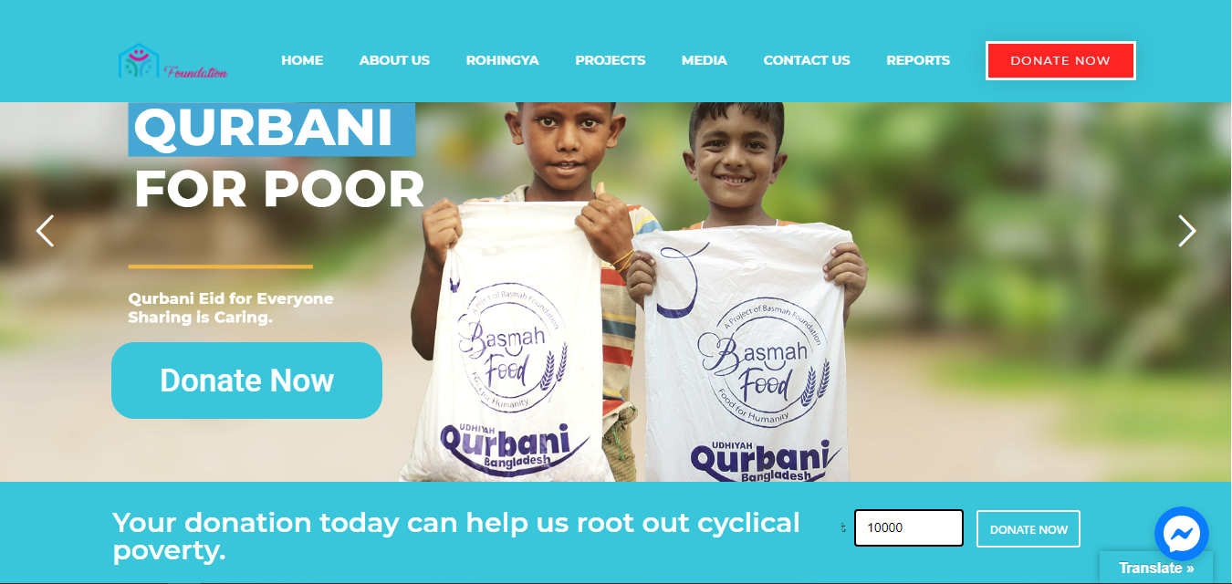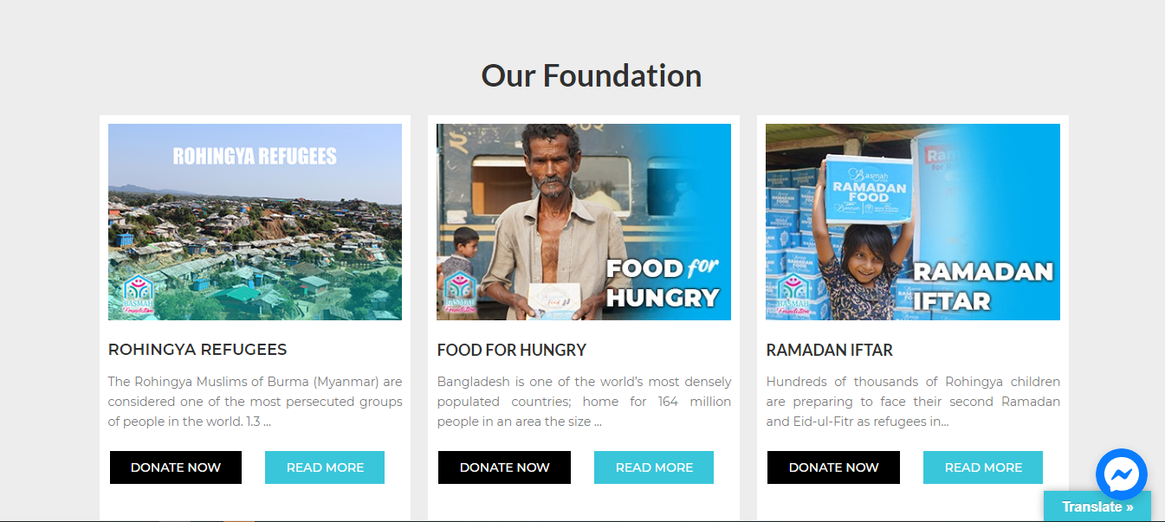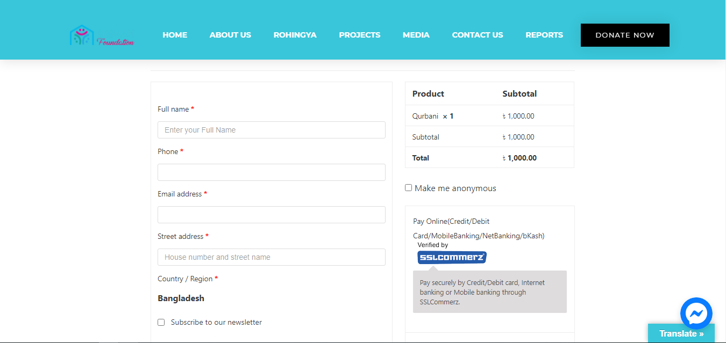

The site of BASMAH establishment has a steady blue shading plan, a limit of around three tones is utilized to draw the client's consideration; an excessive number of tones can do the contrary impact. While giving, it is a basic cycle of filling in your own subtleties, the gift interaction is simple, and the site furnishes you with simple visual connections to how much the client needs to give.

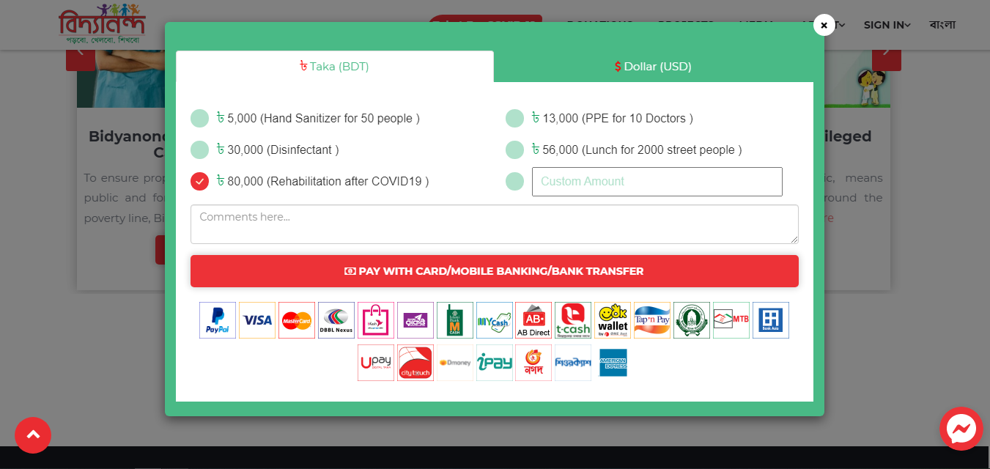

Fig 2: BIDDYANONDO foundation home page, projects, donation page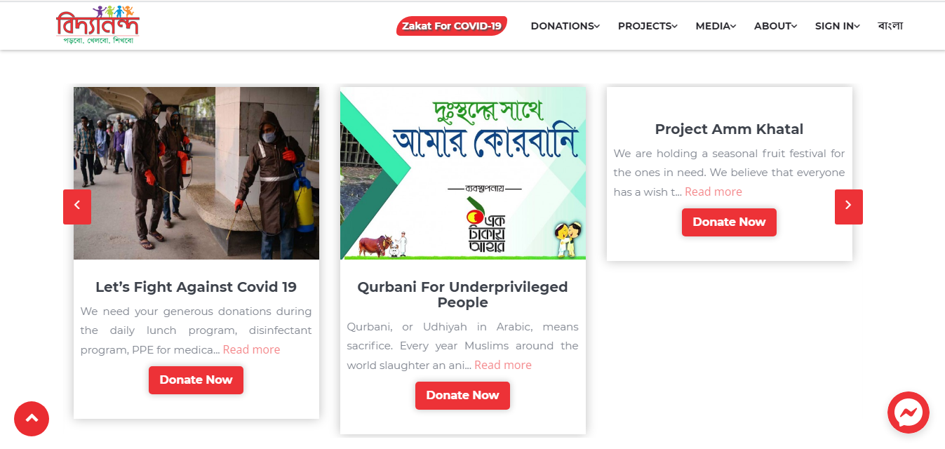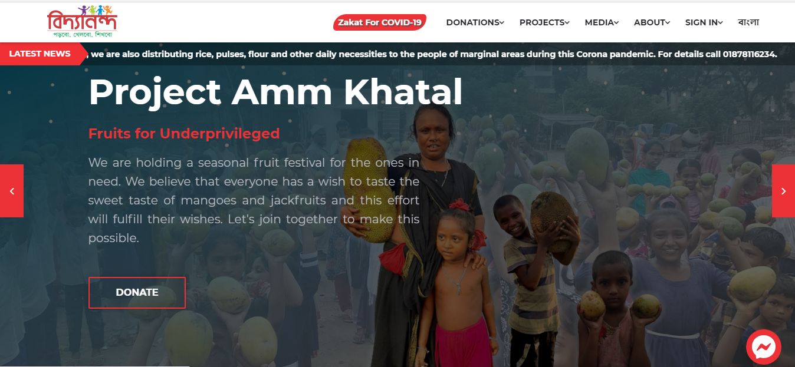

The BIDDYANONDO Foundation is a fundamentally the same as application to the one that will be fabricated, it permits the client to give cash, garments. The gift interaction is basic and the sort of style that we will carry out into my web application, is planned insightfully with catches and insignificant content. As demonstrated from the figure, it is an extremely straightforward interaction with a perfect interface, which is something that ought to be considered when assembling the application.

# **Ethical Issue**

To conduct this software project, a profound survey is carried out via google form and our own research on the similar project applications. The survey method is the best for a software project like ours, reason, it is an extensive way for gathering data to describe, illustrate on a given domain. The detailed data received from the survey of this project is described in Data Collection Method (2.2). The Data Collection Method does not contain all follow-up questions answers might, therefore, be hard to replicate. It is, however not possible to know whether the people who attended the survey told the truth or not, but there were no conflicting statements made and there is no apparent reason for why they should lie. The major ethical issues in conducting software project are-

* Respect respondents’ privacy
* Respect for anonymity and secrecy
* No fraud in collecting data.

These ethical issues were maintained in conducting our software project survey and data collection process. While doing survey, every respondent’s identity has been kept anonymous via google forms. Our survey form was shared in different social groups, from where we have collected required data to conduct our survey. Which means there is no fraud in collecting data. All the participations were voluntary and there was no fine involved in rejection to participate. To remain neutral and not hurt any participants, questions of our survey were chosen carefully.

# **CHAPTER 3: PROJECT PLAN**

# **3.1 Project Effort Estimation**

An estimation of each task using COCOMO81 model is given below-

Since this is an organic system, the value of coefficient is 2.4, project complexity (p) is 1.05, KLOC is 15, T is 0.38

1. Effort= PM = Coefficient<Effort Factor> * (KLOC) P

         = 2.4 *(15) 1.05

= 41.21 person-month

1. Development Time= DM = 2.50 * (PM) T

      = 2.50 * (41.21) 0.38

           = 10.27 Months

1. Required number of people = ST = PM / DM

       = 41.21**/**10.27

         = 4.01 ~ 4 Persons

**Hardware Requirements-**

Server side:

* Any Pentium or equivalent processor
* RAM: 16GB
* System Type: Windows (64 bit)
* Storage: 256GB SSD
* For storage service: Network File System (NFS)

Client side:

* Processor: Dual Core
* RAM: 2GB
* System: Windows, MAC OS X, Linux, Android, IOS
* Web Browser: Firefox, Google Chrome, Opera, Brave

**Software Requirements:**

* Notepad/Sublime text
* PHP, MySQL
* Apache

**Other Requirements:**

* SMS integration service
* Email server: SMTP, POP3
* Donation Software
* Google Analytics

**Domain and Hosting**

Hosting Package C: For the demanding sites

* 5 GB SSD Storage
* 150 GB Bandwidth Monthly
* RAID 10 SSD Server
* Lite Speed Web Server
* Five Addon Domains
* Unlimited Sub Domains
* Unlimited Email Accounts
* Unlimited Databases

Tk. 3500/year

**Estimated Budget**

|  |  |
| --- | --- |
| **Description** | **Cost Assumption (BDT)** |
| Internal resource/ Staff costs | 30,000 |
| Software, Hardware, Network, Labor costs | 1,10,000 |
| Developers costs | 2,00,000 |
| Support costs | 6000 |
| Office costs | 25,000 |
| Other costs | 10,000 |
| **Total** | **3,81,000/=** |

# **Project Planning**

**Work Breakdown Structure (WBS)**

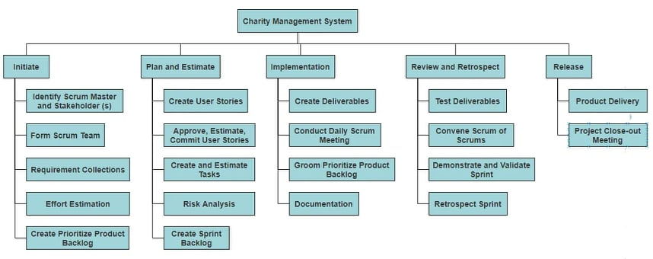   
Fig 3: Work Breakdown Structure

**Scheduled Tasks and Duration (Gantt Chart)**

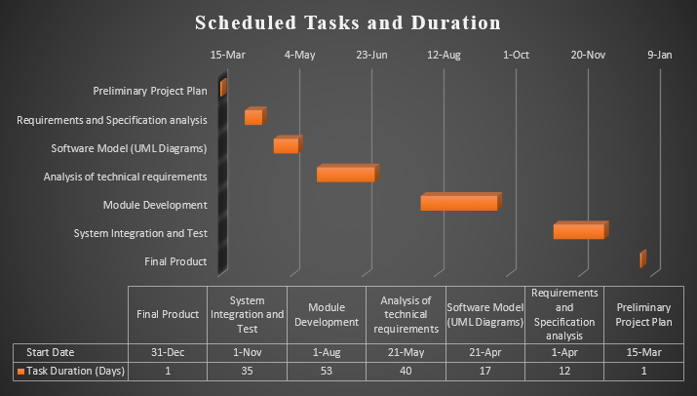

Fig 4: Gantt Chart showing the scheduled tasks and its duration.

**Budget Breakdown**

|  |  |
| --- | --- |
| **Description** | **Project Expenditures (BDT)** |
| **Internal Resources/Staff Cost**   * Information Department * User Department * Procurement Department * Travel and Expenses * Consultancy assistance * Legal assistance | 3000  6000  4000  2500  3 500  5000 |
| **Total** | 24,000 |
| **Software Costs**   * Application user licenses * Software Modification * Database user licenses * Operating System * Additional security applications | 21000  1000  5000  3000  0 |
| **Total** | 30,000 |
| **Hardware Costs**   * Servers * PC’s * Additional Memory * Additional CPU * Additional processing services * Printers * Scanners * UPS * Back up devices * Disk Storage | 20000  25000  0  0  0  5000  4000  3000  2000  2000 |
| **Total** | 61,000 |
| **Network Costs**   * Cabling or wireless LAN, WAN * Racks * Routers * Switching devices * Modems * Leased or dedicated lines * Communication software | 5000  1000  3000  0  0  5000  0 |
| **Total** | 14,000 |
| **Labor Costs**   * For implementation tasks | 2000 |
| **Total** | 2,000 |
| **Project Team**   * Project Manager * System and Database Analyst * Software and Installation Engineer * Programmers * System Testers * Additional Team | 50,000  30,000  25,000  45,000  25,000  5000 |
| **Total** | 1,80,000 |
| **Support Costs**   * Clint Manager * IS support * Networking support | 2000  3000  0 |
| **Total** | 5,000 |
| **Office Costs**   * Temporary office accommodation * Furniture, Stationery, supplies * Telephone lines * Communication costs | 5000  10000  5000  2000 |
| **Total** | 22,000 |
| **Other Costs**   * Internal Audit review * Project steering group * Networking with other organizations | 3000  2000  3000 |
| **Total** | 8,000 |
| **Overall Total** | **3,46,000/=** |

# **Uncertainties and Risk Analysis**

|  |  |  |  |  |
| --- | --- | --- | --- | --- |
| **S/N** | **Risk Description** | **Probability** | **Impact** | **Mitigation Plan** |
| 1 | Unrealistic time estimate | 40% | High | Take multiple estimation. |
| 2 | Loss of work due to equipment failure/loss | 30% | High | Weekly data backup to Hard drive. |
| 3 | Unavailability of API’s | 20% | Medium | Alternative API’s will be checked for. |
| 4 | Developers needs to hardware or software requirements | 5% | Medium | Select best available hardware or software components. |
| 5 | Exceeding budget | 15% | Medium | Some extra budget needs to be added. |
| 6 | Testing and debugging error | 10% | Medium | Adopting qualitative testers. |
| 7 | Failure of server | 10% | Low | Backup system database regularly. |
| 8 | Staff/Personnel shortfall | 5% | Low | Take 2/3 extra members in the team. |
| 9 | Lack of return/diversity of investment portfolio | 7% | High | Investment policy set by trustees. |
| 10 | Unsatisfactory fundraising | 20% | High | Financial appraisal of new projects |

# **Project Execution**

**Project Deliverable Plan**

|  |  |
| --- | --- |
| **Description** | **Date** |
| 1. Preliminary Project Plan | 15.03.2021 |
| 1. Requirements and Specification analysis | 01.04.2021 - 20.04.2021 |
| 1. Software Model (UML Diagrams) | 21.04.2021 - 20.05.2021 |
| 1. Analysis of technical requirements | 21.05.2021 - 31.07.2021 |
| 1. Module Development | 01.08.2021 - 30.10.2021 |
| 1. System Integration and Test | 01.11.2021 - 30.12.2021 |
| 1. Final Product | 31.12.2021 |

**Work Distribution of the Project Works**

|  |  |  |  |  |
| --- | --- | --- | --- | --- |
| Role | ID | Name | Working Hours (Estimated) | Operational Area |
| Project Manager | 100 | Mustafizur Rahman | 1080 | All Phases |
| Requirements Analyst | 101 | Rahat Maksud Pranto | 88 | Requirements collection and feasibility study |
| Software Engineer | 102 | Sanjida Afrose Rikta | 136 | System design and allocation |
| Developer | 103 | Shameem Shahriar | 416 | System implementation |
| Database Manager | 104 | Rahat Maksud Pranto | 138 | Design and Implementation |
| Tester | 105 | Mustafizur Rahman | 280 | Requirements analysis and quality testing |
| Installation Engineer | 106 | Sanjida Afrose Rikta | 100 | Installation |

N.B. – Total working day 160. All the staffs will work 4 days a week and 8 hours a day. As emergency can occur anytime so we have taken 3 extra people in the team so that they can work in absence of any regular team member.

# **CHAPTER 4: RESULTS AND ANALYSIS**

# **Solution Description**

This section describes the functional, non-functional, project requirements that are necessary in the system/project development. We have done two types surveys. First one was about the applicability of charities among the people and how often they are engaged with charities. From the survey it was found that people like to do online donation via mobile banking and so, we added various types of mobile banking in our system along with banking system. In the second survey we reviewed some similar websites and tried to solve some of their lacking e.g., there is no option for any emergency help, donation history of users so we added them in our system. Though most of the functionalities are same but we took those that are required for our system e.g., we have integrated PCI DSS into our system.

# **4.1.1 Functional Requirements**

Functional requirements describe what our system should do, and what the user expects from the fully developed system.

**1. User Registration**

**Functional Requirements**

1. The system should allow the users to do registration with valid information.
   1. After clicking on register, a new interface will appear and it will ask user’s name, mobile number, email address.
   2. After entering the details, a username and password will be sent to user’s email.

**Priority-** High

**Precondition –** User must have a valid mobile number and an email address.

**Crossover –** 2.1

**2. Login and Change Password**

**Functional Requirements**

* 1. The system will allow users to login into the system with their given username and password. After a successful login the homepage should appear.
  2. The system should allow the users to change their initial given password.
  3. The users must change the initially assigned login password after the first successful login.

**Priority-** High

**Precondition –** User must have a validaccount and have to login at least once.

**Crossover –** 1.3

1. **User Management**

**Functional Requirements**

* 1. Only financial managers should be allowed to create, modify, or delete data stored in the system.
  2. When donation the system should ask the users if he/she want to share his/her details to public, if he/she wants to publish then the name and amount will be displayed but if he/she does not want to share their data then the information of the donors will not be published to other users.
  3. Each unsuccessful attempt by a user to access any data of information will be monitored.
  4. Users will get a message if there is any change of information in his/her profile.

**Priority-** High

**Precondition –** There should be some change of data in user’s account.

**Crossover –** N/A

1. **Online Donation and Security code**

**Functional Requirements**

* 1. For donation the system should accept credit cards, debit cards, mobile banking services like Bkash, Rocket, Nagad.
  2. After the user choose any option from the (Bkash, Rocket, Nagad) then a verification code will be sent to user’s number and the application will ask to enter the code for further procedure.
  3. After the user choose any option from the (VISA or Cards) then the application will ask to enter the card info. If the card info is correct then the application should proceed.

**Priority-** High

**Precondition –** User have to donate some money first.

**Crossover –** N/A

1. **Urgent Help**

**Functional Requirements**

* 1. The system should have an urgent donation section where an application form will be there. Sometimes poor people face serious health issues and need urgent help for treatment. These needy people can apply for urgent help.
  2. In the application form the system should ask the user’s address, mobile, reason of asking help in details.

**Priority-** Low

**Precondition –** User have to choose Urgent Help option at first.

**Crossover –** N/A

1. **Donation Type**

**Functional Requirements**

* 1. The system shall allow to choose the user in which type of donation user want to contribute.
  2. The system should have at least two types of donation category, by cash or online donation.

**Priority-** High

**Precondition –** User have to choose donate option.

**Crossover –** N/A

1. **Donation Category and Amount**

**Functional Requirements**

* 1. The system shall allow to choose the user in which type of donation user want to contribute. Ex.- Education, Relief, Clean water etc.
  2. The system should ask the user how much money they want to donate.

**Priority-** Medium

**Precondition –** User have to choose donate option.

**Crossover –** N/A

1. **Password Recovery**

**Functional Requirements**

* 1. If the user inserts wrong password, he will be given a warning and after three unsuccessful attempts the account will be locked and a new password should be sent to user’s email or mobile number if user clicks forget password option and by this code the user can login to the system.
  2. If the user forgets password, he can request for a new password by clicking forget password option.
  3. The system should send a verification code to user’s mobile number or email and ask to submit the code to verify whether the number or email belongs to an account or not.
  4. If the code matches then a new password should be sent to user’s mobile number or email as per his/her choice otherwise system will show an invalid message.

**Priority-** High

**Precondition –** User must submit invalid pass couple of times.

**Crossover –** 1.3

1. **Personal Information and Donation History**

**Functional Requirements**

* 1. The system should allow the users to see their donation history, when and in which category and how much they have donated after successful login.
  2. The system should allow the users to see their personal information.

**Priority-** Medium

**Precondition –** User must login to their account.

**Crossover –** 2.1

1. **Information and Email**

**Functional Requirements**

* 1. The system should allow the admin to show individuals’ fund and details.
  2. The system should allow the admin to send emails after successful donation or for other updates.

**Priority-** Medium

**Precondition –** N/A.

**Crossover –** N/A.

# **4.1.2 Non-Functional Requirements**

The non-functional requirements describe how well the system works, and how the system should behave in various conditions.

**1. Website Capacity**

**Non-Functional Requirements**

* 1. The website should be capable of handling one thousand users at a time without affecting its performance.

**Priority-** Medium

**Precondition –** N/A

**Crossover –** N/A

**2. Portability**

**Non-Functional Requirements**

* 1. The website should be portable. So that moving from one OS to another OS does not create any problem. It should work in Windows, Linux and Mac.

**Priority-** Medium

**Precondition –** N/A

**Crossover –** N/A

**3. Usability**

**Non-Functional Requirements**

* 1. The system should be fast for the users to complete their actions once they see the interface, to reach their goals it should take 2 to maximum 3 minutes.
  2. The interface should be easy to understand so that the users do not make any mistake while submitting their payment details and it should not take more than 5 minutes.

**Priority-** Medium

**Precondition –** N/A

**Crossover –** N/A

**4. Integrity**

**Non-Functional Requirements**

* 1. The payment processing gateway of the system will be PCI DSS based.
  2. No malware or virus and any kind of unauthorized access can access or harm any kind of data.

**Priority-** High

**Precondition –** N/A

**Crossover –** N/A

**5. Efficiency**

**Non-Functional Requirements**

* 1. After running the app there should be at least 50% space in the RAM and processor at its peak condition.

**Priority-** High

**Precondition –** N/A

**Crossover –** N/A

**6. Reliability**

**Non-Functional Requirements**

* 1. After running the app, the system should be reliable. If it runs 100 times it should not fail to run and give service more than 10 times.

**Priority-** High

**Precondition –** N/A

**Crossover –** N/A

**7. Flexibility**

**Non-Functional Requirements**

* 1. The system should be flexible. It should not take more than 2 to maximum 3 hours for developers to add new features if needed.

**Priority-** High

**Precondition –** N/A

**Crossover –** N/A

**8. Interoperability**

**Non-Functional Requirements**

* 1. As there are donation operations, the system needs to collaborate with bank and other mobile banking service. So, the system should provide nonstop service until there is any issue in bank or mobile banking.

**Priority-** High

**Precondition –** N/A

**Crossover –** N/A

**9. Reusability**

**Non-Functional Requirements**

* 1. Some common features like login and registration can be reused from another project and the system should adapt this easily.

**Priority-** Medium

**Precondition –** N/A

**Crossover –** N/A

**10. Maintainability**

**Non-Functional Requirements**

* 1. A maintenance programmer should be able to modify an existing report or function within 20 labor hours.

**Priority-** High

**Precondition –** N/A

**Crossover –** N/A

# **4.1.3 Design Specification (UML Diagrams)**

**Use Case Diagram Scenario**

A donor has to register into the system for knowing details about the application and donation money. For registration a donor has to submit his name, address, mobile number and email address. After a successful registration the donor will get an id and password. Donors can log in into the system using the username and password. Then donor can make donation by mobile banking like Bkash, Rocket or Nagad or via Visa or MasterCard certified bank cards and Bank transfer. There will be campaign which will be held by some volunteers in every month for collecting money. The volunteers will come to the financial manager and submit the collection of donations. The financial manager will add the money to the fund and update the current balance of charity account. There will be an emergency help center which will be used only for emergency purpose. If a person needs emergency help, he/she can apply for money by submitting an application in offline by vising office or online. Each submitted application will be reviewed by application reviewer. The reviewer will forward the reviewed application to a (skilled and trustful) verifier team who will verify the application by visiting the applicant’s address. Every verified application will be forwarded to the financial manager and the manager will grant the permission to hand over the money to the applicant. System will transfer the granted amount of money to the applicant’s bank account. The system will ask the donor if he wants to publish info while donating in their website or not. If yes, the system will publish donor’s info(name) and the amount of given money. Else the system will say that applicant’s name is anonymous and will publish other information.

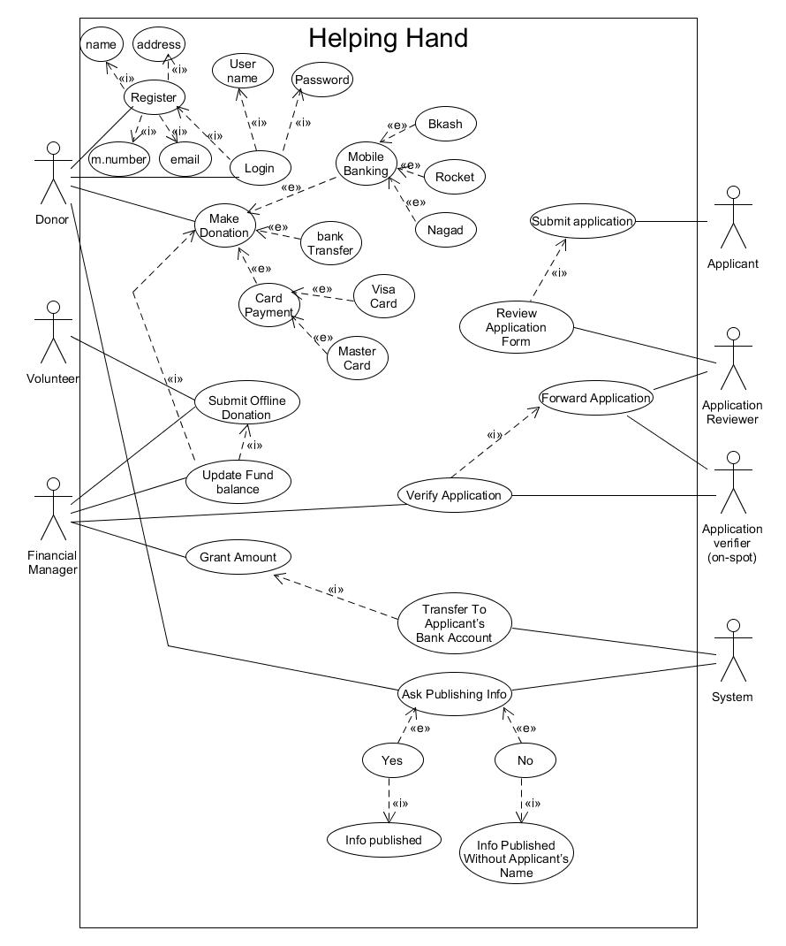

Fig 5: Use Case Diagram

**Class Diagram Scenario**

* Every donor, employee and manager must log in for details.
* Donor can donate money as many times as donor want.
* Employee will verify the applications submitted by the applicants.
* Financial Manager will give money to the applicants and the applicant will receive the money.
* Fund will be updated in website by the financial manager.
* Registered donor can check his money transection details.

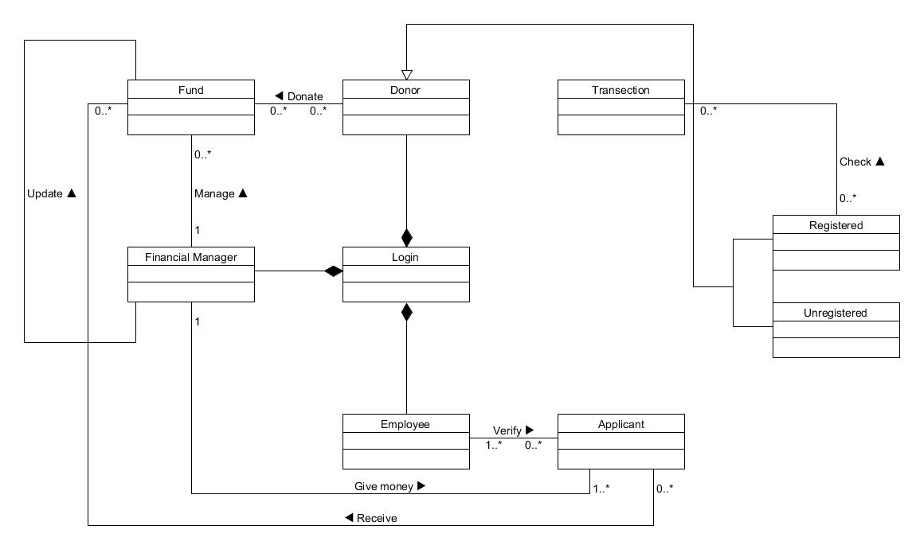

Fig 6: Class Diagram

**Activity Diagram Scenario**

**Scenario for Donor:** When a donor enters into the application, he/she will have options for choosing, he/she can choose login, donate, registration. To donate, the system will ask him to enter donation amount. Then the system will show payment method for donor. Donors have three options to donate, one is card payment, second is bank transfer and the third one is mobile banking. Card payment has also two options, they are visa and master card. Mobile banking has three options as well, they are Bkash, Rocket and Nagad. By any of that he/she can easily donate money successfully. If a donor wants to know more details, he/she has to login into the system. When he/she click login button he/has to enter his/her password. If the is correct he/she will be logged into the system and see other details but if the password is incorrect system will ask him to enter password again. If the donor types incorrect password more than three times his/her account will be blocked and a new password will be generated and sent to his email.

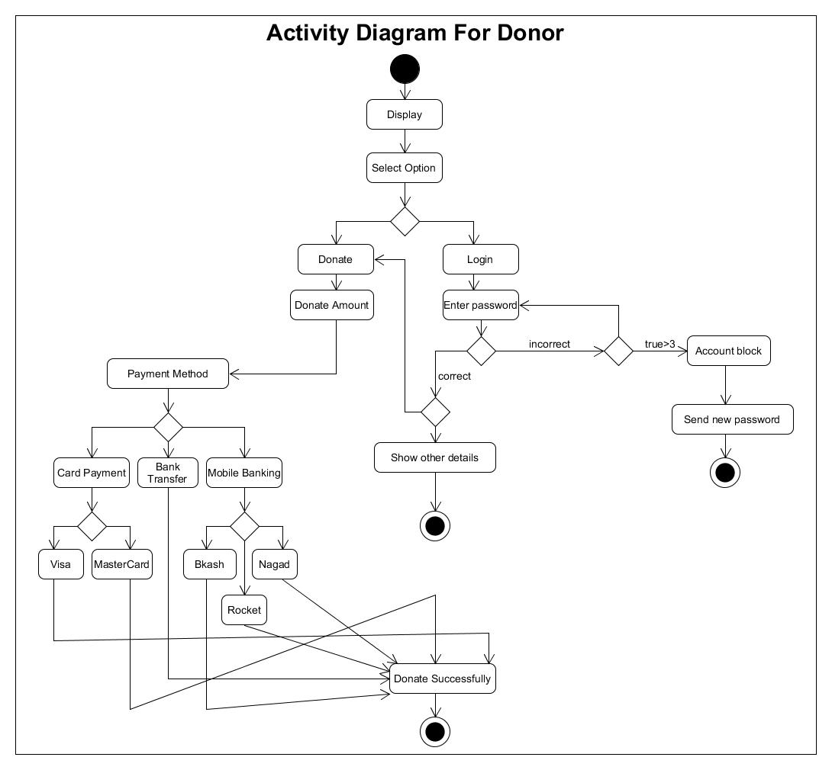

Fig 7: Activity Diagram (Donor)

**Scenario for Applicant:** There is an emergency site for. Those who need money they can apply for emergency help. An applicant can apply both in online and offline. For online applicants need to enter into the application and choose Emergency help button. Then the system will ask him to fill up an application form and the form will be stored in the database. A team will verify the application. If the application gets verified the system will approve the application and transfer the money to the applicant’s bank account. If the application does not get verified the system will cancel the application. For offline applicant has to collect the form from office and submit it filling up the details.

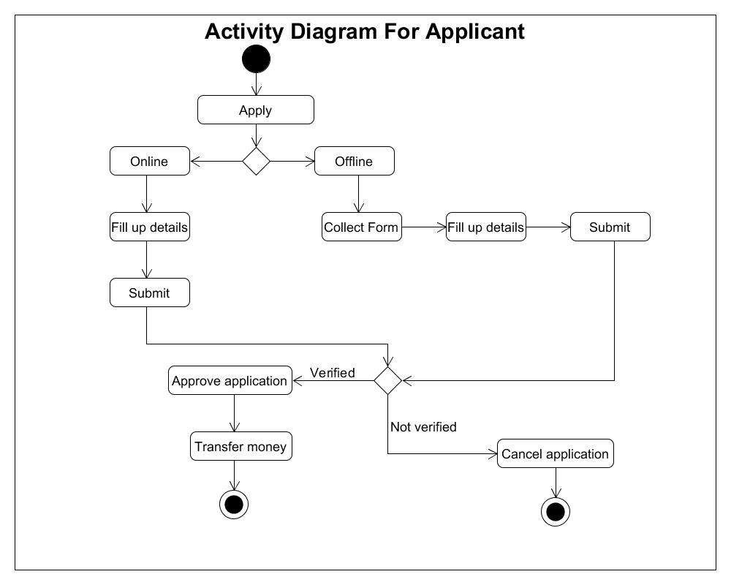

Fig 8: Activity Diagram (Applicant)

**ER Diagram Scenario**

We have designed an application named “Helping Hand”. It is a donation-based application. By using the software people can get into the system and can donate. Donation can be done both in online and offline. Donors who want to know more details have to register in the app. For registration they have to provide their name, email and mobile number. Donor must have a valid mobile number which will be unique for every donor. The system has admin who will provide the donors login details which are unique id and password after successful registration. Offline donation will be collected via campaign which will be held every month. There will be a booth where people can donate. After a successful registration a donor can log into the system. Donor can donate using their bank account, credit card, debit card as well as via mobile banking using Bkash, Rocket and Nagad. Donor can select donation type. The types are public and private. For public donation the info of the donor will be shown in the application on the other hand for private donation only the amount will be shown. The system has financial manager who can modify, delete, create, hide any data in the system. After a successful donation a digital tax receipt will be generated and will be sent to donor’s email address and confirmation message will be sent to his/her mobile number. The system has an emergency helping site where an application will be there. People who need urgent help can fill up the application for asking help. While filling up the application the system will ask the applicant to submit his/her address, mobile number and reason of asking help. A team will visit the applicant’s address to verify the situation. There will be a committee who will decide the confirmation of the application after the team’s confirmation about the applicant’s situation. If the application has been approved then an amount of money will be handed over to the applicant and the amount will be decided by the committee after understanding the emergency situation.

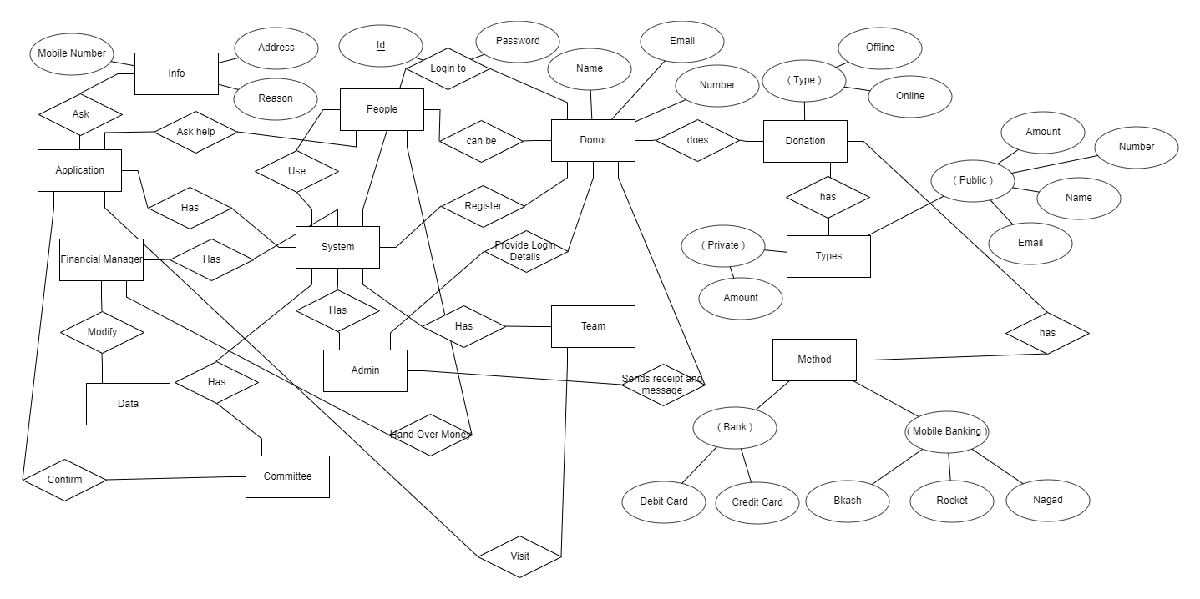

Fig 9: ER Diagram

# **4.1.3 UI/UX Design**

Some user interfaces of our websites are shown below-

|  |
| --- |
| Fig 10: Home Page  Fig 11: Join Us  Fig 12: Projects |
| Fig 13: Our Foundation  Fig 14: Our Team |

|  |
| --- |
| Fig 15: Donation |
| Fig 16: Blogs  Fig 17: Contract Us |

# **4.2 Impact on Environment:**

In recent years, the attention of the world has never been more focused on environmental responsibility. Every aspect of society, including business, and individuals, is being encouraged to behave in more environmentally friendly ways to assist ensure not only today's but also future generations' quality of life. So, it's very important to find the impact of our application “Helping Hand” on environmental factors.

Natural issues are resolvable, and charities can give openings for individuals to act. Our charity application can play a crucial part in handling natural issues, as pioneers, pioneers. Charities move quicker than governments to create data, alarm the open to squeezing imperative issues, deliver groundbreaking inquire and reports by looking over, and try with arrangements since Charities work freely.

Compared to other sectors, charities have been far quicker to notice and respond to the problems provided by the link between poverty and environmental deterioration [7]. Environmental charities are demonstrating how ecosystem restoration and management may enhance the livelihoods of people in underdeveloped countries.

The justification for preserving biodiversity and moderated ecosystems can be argued for economic, social, and aesthetic grounds. Solid ecosystems help the globe produce food and other materials: crops cannot fertilize without pollinators, and rainforests not only provide lumber but also hold restorative plants that provide remedies for human diseases. [6] People value the common world for a variety of social, social, and spiritual reasons. Human squandering of resources, territorial devastation, pollution, the introduction of invasive species and diseases, and climate change all pose threats to the environment and biodiversity.

Charities also protect against corporate environmental irresponsibility, which frequently interacts with human rights. To make our civilization more sustainable, we must reduce carbon and pollution emissions while also stabilizing resource use. Funding is required across the environmental sector, but there are a few sectors where more funding might make a big difference:

* Seed money for organizations working in the new field of climate change;
* Supporting initiatives in underdeveloped nations that provide sustainable livelihoods;
* Environmental certification programs should be scaled up and replicated;
* Thoughtful and focused assistance for campaigning and lobbying should be provided; and
* A strategic strategy to assisting ecosystems and biodiversity conservation organizations in making more success.

Our charity will approach capable speculation from the point of view of social, natural, moral or administration hazard administration. We'll be particularly concerned almost companies which have a tall introduction to this region and look for to get it how these companies will oversee and moderate the coming about dangers in arrange to way better protect our longer-term speculations.

# **4.3 Lifecycle Analysis**

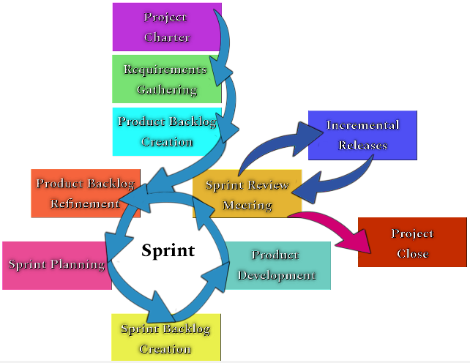

Fig 18: Scrum Lifecycle

**Lifecycle of the Software Development Process**

A Project Charter need to be created initially which lays out a simple framework of the undertaking and is used to claim the life of an undertaking and provide it permission to continue with undertaking activities. A Scrum Master wishes to be decided on for the team as well, and that they may be diagnosed inside the Project Charter. After that a continuation of the Requirements Gathering, core duties want to be taken and begin to interrupt matters down into comprehensible chunks. By the end of the creation of the Backlog, and earlier than beginning the Sprints, it wishes to be ensured that there's a task kick-off assembly and obtained formal approval of the Product Backlog. Product Backlog Refinement can surely arise at any time; however, it wishes to be ensured that it's far updated and prioritized earlier than a brand-new Sprint is planned. The Sprint Planning Meeting (TSPM) is a month to month gathering when the Item Proprietor and Group examine what will be fulfilled amid the taking after Sprint, which typically lasts 30 days. During this meeting, the Sprint Backlog will be created, a listing of all of the gadgets the improvement crew plans to finish withinside the present-day Sprint. The Sprint Backlog may be adjusted and modified throughout the Sprint. The Daily Scrum Meeting (TDSM) is a 15-minute status meeting where developers discuss what has been accomplished since the last meeting, what items will be completed before the next meeting, and any difficulties they face. The Daily Scrum is a part of the Product Development phase.

At the cease of the Sprint, a chunk of the product is positioned up for inspection. They will exhibit this piece for the client of the mission and the client can also additionally pick to just accept or reject it. Ideally, the clients might offer positive comments to assist manual them via the following Sprint. This is a massive a part of monitoring & controlling the mission. Every Sprint through Scrum is a possible “closing Sprint” with a few initiatives, different initiatives you realize approximately how lengthy and what number of Sprints kind of it could take assuming no large changes. The selection on whether or not the task is feasible for every other Sprint must be made all through the Sprint Review on the latest. During last, it may nonetheless be useful to keep a lesson found out meeting. It is time to search for methods to enhance withinside the subsequent task and have fun successes withinside the last task.

**Sustainability of the proposed Application**

Creating and running an application requires funding. We can think of several ways how the proposed application would be managed to operate its functionalities with required funding (e.g., how the application will earn sufficient revenue to spend on its operational costs, etc.)

* **Fees from private sources:** Private sources such as independent private organizations/business farms or individual person can be reached out with proposal and description of the necessity and costing of the application. Upon consideration they might be interested to pay for the operational costs.
* **Government grants and contracts:** A government grant is a financial award given by the local government authority for a beneficial project. It is effectively a transfer payment. The grantee isn't expected to reimburse the money but is anticipated to utilize the reserves from the allow for their expressed reason, which regularly serves a few bigger great. It is exceedingly prestigious to get a government allow and regularly brings a person or substance to the consideration of other givers or sources of income. So, the grants can be used to fund the operation of the application.
* **Private Contributions:** Private contribution may also be called gifts or grants. Essentially gifts, grants and contributions refer to the same thing – value given by a donor without receiving commensurate value in return. Our application can earn its operational revenue from these kinds of contributions. Even pledges from contributors can ensure the funding.
* **Sponsorships:** We can receive sponsorships from various individual companies. In return we will run adverts of the companies on our application. This will act as a marketing strategy for the companies. And we will use the sponsorship to keep our application running.
* **Corporations:** There are corporations which will be interested to support us just because of our overall goals. We can use their support as donations to spend on the operational cost of our application.

# **4.4 Solution Verification**

Test cases were conducted to verify the Functional and Non-Functional requirements.

|  |  |  |  |  |  |
| --- | --- | --- | --- | --- | --- |
| Project Name: Charity Management System | | | Test Designed by: Mustafizur Rahman | | |
| **Test Case ID: FR_1** | | | Test Designed date: 20-07-2021 | | |
| Test Priority (Low, Medium, High): High | | | Test Executed by: | | |
| Module Name: User Registration | | | Test Execution date: | | |
| Test Title: Verify registration with name, valid mobile number and email address | | | | | |
| Description: Test website registration page whether the user is successfully registered into the application | | | | | |
| Precondition (If any): User must have a valid mobile number and an email address | | | | | |
| Test Steps | Test Data | Expected Results | | Actual Results | Status (Pass/Fail) |
| 1. Go to the app 2. Enter name 3. Enter mobile number 4. Enter email address 5. Click register | Name: MD. Hasan  Mobile: 01715678901  Email: hasan@gmail.com | User should register into the application | |  |  |
| Post Condition: User is validated with database and successfully registered into the application. The account session details are logged in the database. | | | | | |

|  |  |  |  |  |  |
| --- | --- | --- | --- | --- | --- |
| Project Name: Charity Management System | | | Test Designed by: Shameem Shahriar | | |
| **Test Case ID: FR_2.1** | | | Test Designed date: 20-07-2021 | | |
| Test Priority (Low, Medium, High): High | | | Test Executed by: | | |
| Module Name: Login and Change Password | | | Test Execution date: | | |
| Test Title: Verify login with valid username and password | | | | | |
| Description: Test website login page whether the user is successfully logged in into the application | | | | | |
| Precondition (If any): User must have valid username and password | | | | | |
| Test Steps | Test Data | Expected Results | | Actual Results | Status (Pass/Fail) |
| 1. Go to the app 2. Enter username 3. Enter password 4. Click login | Username: Hasan07  Password: Ha1243 | User should login into the application | |  |  |
| Post Condition: User is validated with database and successfully login to account. The account session details are logged in the database. | | | | | |

|  |  |  |  |  |  |
| --- | --- | --- | --- | --- | --- |
| Project Name: Charity Management System | | | Test Designed by: Sanjida Rikta | | |
| **Test Case ID: FR_3.1, 3.2** | | | Test Designed date: 22-07-2021 | | |
| Test Priority (Low, Medium, High): High | | | Test Executed by: | | |
| Module Name: User Management | | | Test Execution date: | | |
| Test Title: Verify data modify authority | | | | | |
| Description: Test website database and change data | | | | | |
| Precondition (If any): There should be some change of data in user’s account. | | | | | |
| Test Steps | Test Data | Expected Results | | Actual Results | Status (Pass/Fail) |
| 1. Go to the app 2. Go to database 3. Check edit access 4. Ask user if he wants to publish private info 5. If user wants then publish info otherwise publish only donation amount | Previous Donate amount: 1000  Update amount: 2000 | Only financial manager can update any data  Info will be published as per user’s wish | |  |  |
| Post Condition: Info will be published as per user’s wish | | | | | |

|  |  |  |  |  |  |
| --- | --- | --- | --- | --- | --- |
| Project Name: Charity Management System | | | Test Designed by: Rahat Maksud Pranto | | |
| **Test Case ID: FR_4.2** | | | Test Designed date: 26-07-2021 | | |
| Test Priority (Low, Medium, High): High | | | Test Executed by: | | |
| Module Name: Online donation | | | Test Execution date: | | |
| Test Title: Verify sending verification code and asking info of cards | | | | | |
| Description: Test website donation page | | | | | |
| Precondition (If any): User must choose any of the donation options first | | | | | |
| Test Steps | Test Data | Expected Results | | Actual Results | Status (Pass/Fail) |
| 1. Go to the app 2. Go to donation interface 3. Choose any of the donation options | Bkash  Rocket  Nagad  Card | A verification code should be sent to user or card info should be asked from user. | |  |  |
| Post Condition: User is asked to submit the code which was sent to his/her mobile. | | | | | |

|  |  |  |  |  |  |
| --- | --- | --- | --- | --- | --- |
| Project Name: Charity Management System | | | Test Designed by: Shameem Shahriar | | |
| **Test Case ID: FR_8** | | | Test Designed date: 22-07-2021 | | |
| Test Priority (Low, Medium, High): High | | | Test Executed by: | | |
| Module Name: Password Recovery | | | Test Execution date: | | |
| Test Title: Verify getting warning and receiving new password | | | | | |
| Description: Test website login page whether user gets warning while they input wrong password and gets new password when they click forget password button. | | | | | |
| Precondition (If any): User must have an account | | | | | |
| Test Steps | Test Data | Expected Results | | Actual Results | Status (Pass/Fail) |
| 1. Go to the app 2. Type username and wrong password 3. Click login 4. Click Forget password | Username: Hasan07  Password: 12345 | User should get warning  User should get new password | |  |  |
| Post Condition: N/A | | | | | |

|  |  |  |  |  |  |
| --- | --- | --- | --- | --- | --- |
| Project Name: Charity Management System | | | Test Designed by: Mustafizur Rahman | | |
| **Test Case ID: NFR_4** | | | Test Designed date: 26-07-2021 | | |
| Test Priority (Low, Medium, High): High | | | Test Executed by: | | |
| Module Name: Integrity | | | Test Execution date: | | |
| Test Title: Verify Integrity of the software | | | | | |
| Description: Test if any malware attack or unauthorized access can access any data or not | | | | | |
| Precondition (If any): N/A | | | | | |
| Test Steps | Test Data | Expected Results | | Actual Results | Status (Pass/Fail) |
| 1. Go to the app | User’s Pin number  User’s Card Number and pin  Data of users and about the organization | No unauthorized access or malware attack should harm any kind of data of the application and the system should block all unauthorized access | |  |  |
| Post Condition: N/A | | | | | |

|  |  |  |  |  |  |
| --- | --- | --- | --- | --- | --- |
| Project Name: Charity Management System | | | Test Designed by: Mustafizur Rahman | | |
| **Test Case ID: NFR_5** | | | Test Designed date: 28-07-2021 | | |
| Test Priority (Low, Medium, High): High | | | Test Executed by: | | |
| Module Name: Efficiency | | | Test Execution date: | | |
| Test Title: Verify how much unused space remains | | | | | |
| Description: Test how much resource it consumes | | | | | |
| Precondition (If any): N/A | | | | | |
| Test Steps | Test Data | Expected Results | | Actual Results | Status (Pass/Fail) |
| 1. Go to the app | Use any function | There should be at least 50% space free in ram and processor. | |  |  |
| Post Condition: N/A | | | | | |

|  |  |  |  |  |  |
| --- | --- | --- | --- | --- | --- |
| Project Name: Charity Management System | | | Test Designed by: Mustafizur Rahman | | |
| **Test Case ID: NFR_6** | | | Test Designed date: 28-07-2021 | | |
| Test Priority (Low, Medium, High): High | | | Test Executed by: | | |
| Module Name: Reliability | | | Test Execution date: | | |
| Test Title: Verify Reliability of the software | | | | | |
| Description: Test how many times the software fails | | | | | |
| Precondition (If any): N/A | | | | | |
| Test Steps | Test Data | Expected Results | | Actual Results | Status (Pass/Fail) |
| 1. Go to the app | Run the app 100 times | The system should not fail more than 10 times. | |  |  |
| Post Condition: N/A | | | | | |

|  |  |  |  |  |  |
| --- | --- | --- | --- | --- | --- |
| Project Name: Charity Management System | | | Test Designed by: Shameem Shahriar | | |
| **Test Case ID: NFR_7** | | | Test Designed date: 30-07-2021 | | |
| Test Priority (Low, Medium, High): High | | | Test Executed by: | | |
| Module Name: Flexibility | | | Test Execution date: | | |
| Test Title: Verify Flexibility of the software | | | | | |
| Description: Test how much time it takes to add a new feature | | | | | |
| Precondition (If any): N/A | | | | | |
| Test Steps | Test Data | Expected Results | | Actual Results | Status (Pass/Fail) |
| 1. Develop a new feature and add into the current software | Add PayPal system for donation | The new feature should not take more than 2 to maximum 3 hours for developers to add into the system. | |  |  |
| Post Condition: User will be able to donate using PayPal. | | | | | |

|  |  |  |  |  |  |
| --- | --- | --- | --- | --- | --- |
| Project Name: Charity Management System | | | Test Designed by: Rahat Maksud Pranto | | |
| **Test Case ID: NFR_10** | | | Test Designed date: 30-07-2021 | | |
| Test Priority (Low, Medium, High): High | | | Test Executed by: | | |
| Module Name: Maintainability | | | Test Execution date: | | |
| Test Title: Verify Maintainability of the software | | | | | |
| Description: Test how much time it takes to update an existing feature | | | | | |
| Precondition (If any): N/A | | | | | |
| Test Steps | Test Data | Expected Results | | Actual Results | Status (Pass/Fail) |
| 1. Update an existing feature | Add occupation into registration system | Developers should be able to update the feature within 20 labor hours. | |  |  |
| Post Condition: User should be asked their occupation while registering into the system. | | | | | |

# **CONCLUSION**

We have introduced a system of charity management named “Helping Hand”. The aim of this system is to solve problems regarding online charity or donation services. In Bangladesh there are some existing system with some problems relating to the project objective. In short, the objective is to help those in need. One of the major problems is the communication gaps between the donors and the Charities. Without efficient fund raising, all charities would wither and die, which means that for a charity to flourish in the nineties and beyond, it will need to adopt successful brand marketing strategies to its donation programs.” [7]. When donors see a good enough reason, they will donate. But they will also be interested to know if the donations are being used in the best way possible. This needs to be made clear by the Charities. Our system is web based. The donors are likely to make online donation most of the time. As it is still not that common in Bangladesh, they may hesitate to do so. We have published our works in a way so people can easily know our purpose and ways. In short communicating, getting and distributing donations and doing that the easy and fastest way possible are mainly the goals of the project. Therefore, the aim of this project is to resolve these problems by designing a web-based charity management system in the charity organizations. For our project objective we needed data. And we attempted data collection with survey. We created a questionnaire with relevant questions that answer what we wanted to know from people to complete our objectives. The survey was conducted through online media. This system is developed mainly for our non- profit organization and its end-users but with just few changes the system can also be utilized in many real-world applications. The system is structured around the end user’s requirements but there are some improvements that can be done. This study adds to the current literature by demonstrating that a charity may improve the amount of donations received by branding itself closer to a donor's ideal brand picture of a charity. Furthermore, because it emphasizes the necessity of identifying the characteristics of contributors in order to boost charitable donations through good branding, this validates the relevance of branding in the market of charitable donations.

**Future Studies:** One of the upcoming enhancements will be the addition of new payment ways for contributors. Paypal and Skrill are well-known for money transfers, and they may be included so that persons from outside the nation can give money as well. The system might also provide users additional privileges when it comes to making comments on articles on the internet. Many charitable websites use RSS to promote their content to other websites or clients (Really Simple Syndication). Our website might potentially be improved by integrating RSS to offer newsfeed to websites that promote non-profit organizations. To attract additional donations to the website, the system may be improved by adding forums and videos. The use of google maps to pinpoint the user’s location instead of asking the user to enter their location and a virtual 24/7 chat service can also be added in the future enhancements.

# **REFERENCE**

[3] Alicia Meckstroth. 1994. Nonprofit organizations and charitable giving, 1986–1992: A compendium of statistical information and analyses. *Nonprofit Management and Leadership,* 359-364

[https://doi.org/10.1002/nml.4130040310](https://doi.org/10.1002/nml.4130040310 )

[4] Brain Tumour, Stephen Price (2017). Accessed 1 12, 2017

https://doi.org/10.1186/isrctn14920547

[5] Bryson, J. M. (1988). A strategic planning process for public and non-profit organizations. *Long Range Planning*, *21* (1), 73-81.

<https://doi.org/10.1016/0024-6301(88)90061-1>

[6] Hatten, M. L. (1982). Strategic management in not‐for‐profit organizations. *Strategic Management Journal*, *3*(2), 89-104.  
<https://doi.org/10.1002/smj.4250030202>

[7] Pick, James B. 1991. Staffing, planning, and control of information systems in charitable nonprofit organizations. *Information & Management* 20 (4): 295- 311.

[https://doi.org/10.1016/0378-7206(91)90021-s](https://doi.org/10.1016/0378-7206(91)90021-s )

[8] Saxton, J. (1995). A strong charity brand comes from strong beliefs and values. *The Journal of Brand Management, 2*, 211.

<https://doi.org/10.1057/bm.1995.2>

[9] Wray, R. B. (1994). Branding product development and positioning charity. *Journal of Brand Management*, 363-370.

[https://doi.org/10.1057/bm.1994.20](https://doi.org/10.1057/bm.1994.20 )

# **APPENDIX**

A survey was directed to improve comprehension of the objective clients. This was conveyed to the overall population (through online media) and got more than 100 reactions. The outcomes were gathered are appeared below-

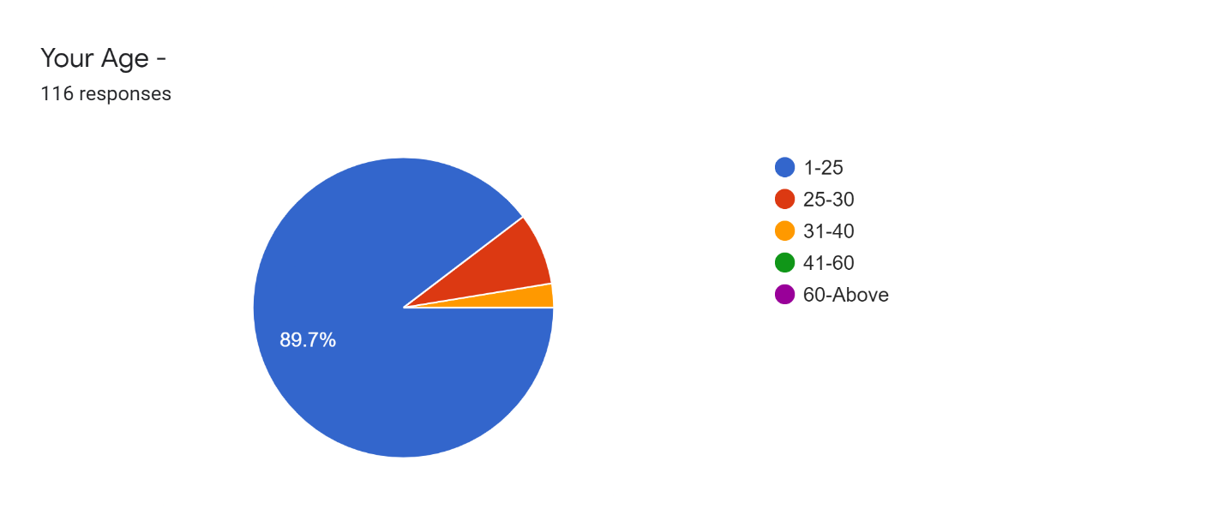

Fig 19: Age

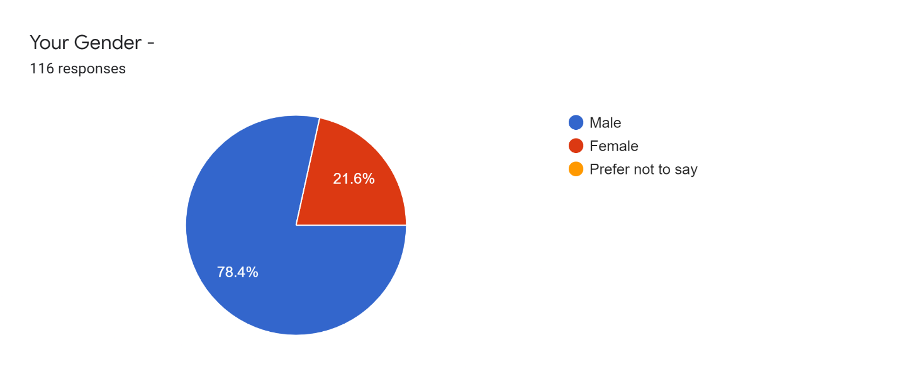

Fig 20: Gender

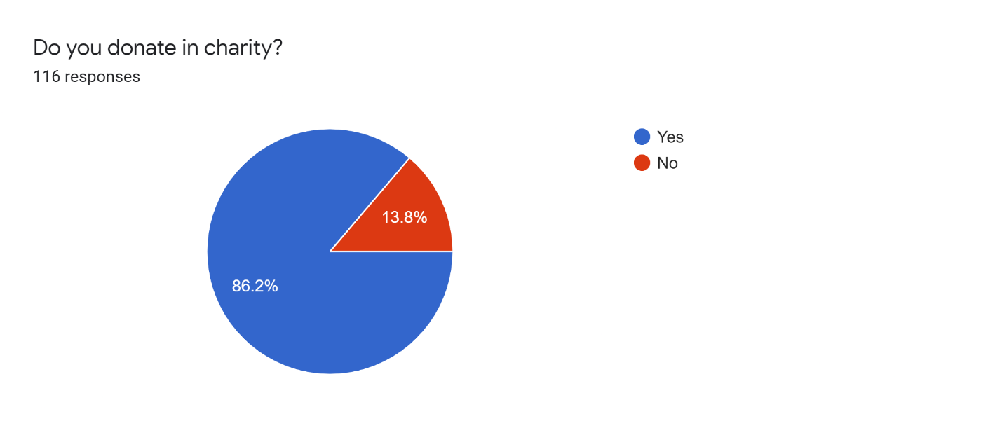

Fig 21: Do the donate in the charity?

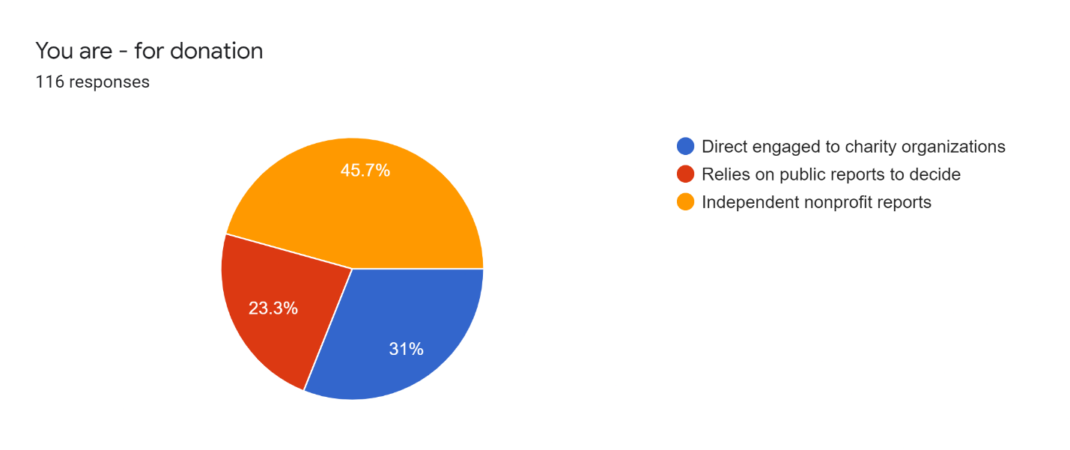

Fig 22: On which basis they decide to donate?

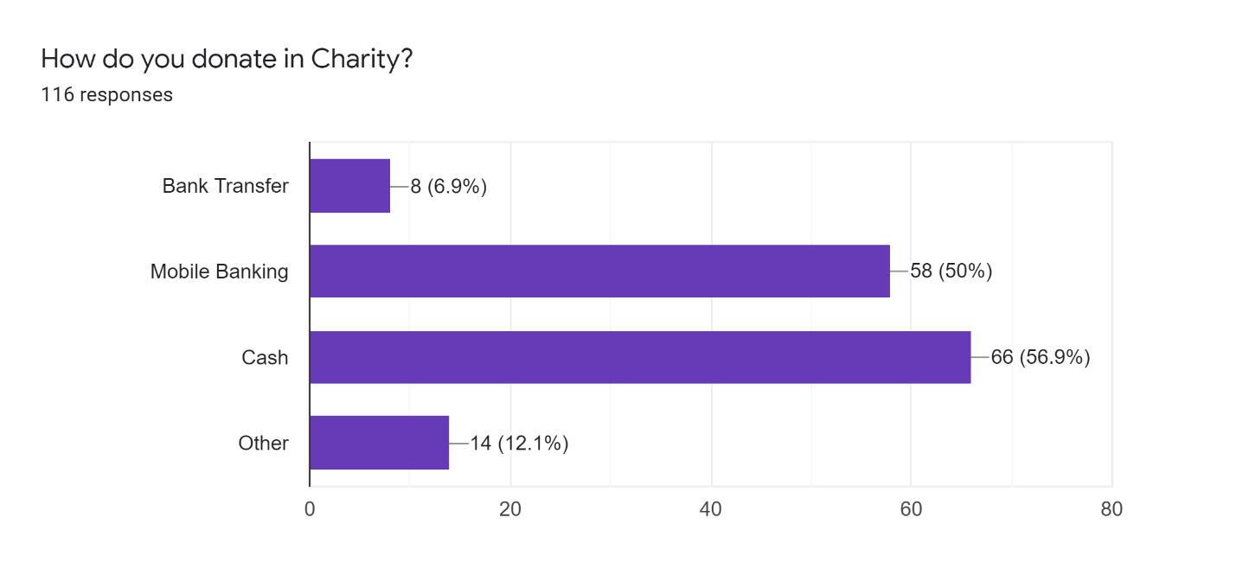

Fig 23: How they donate?

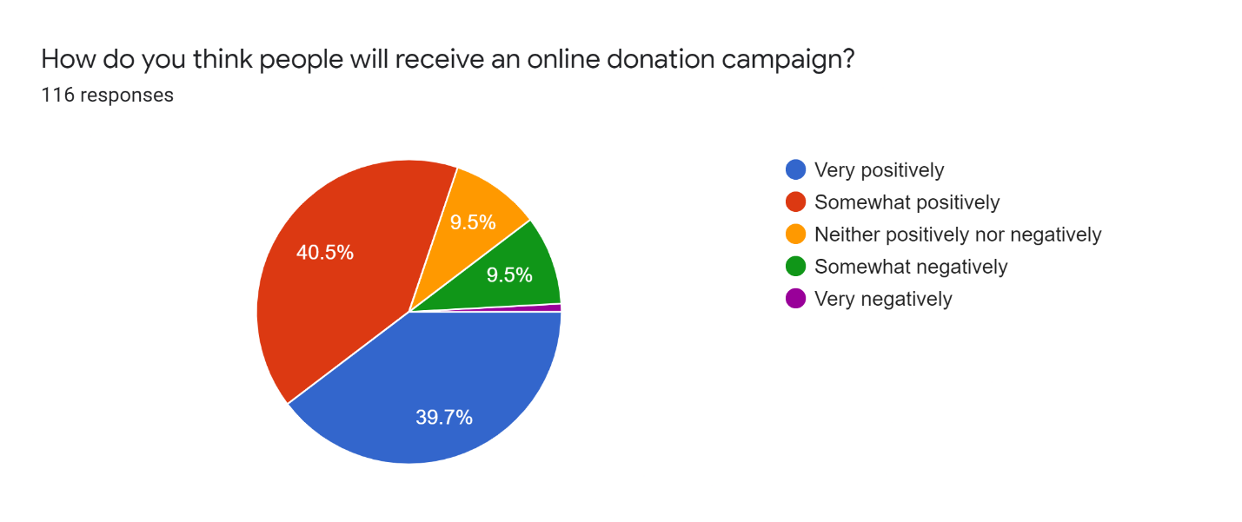

Fig 24: How people will take online donation campaign?

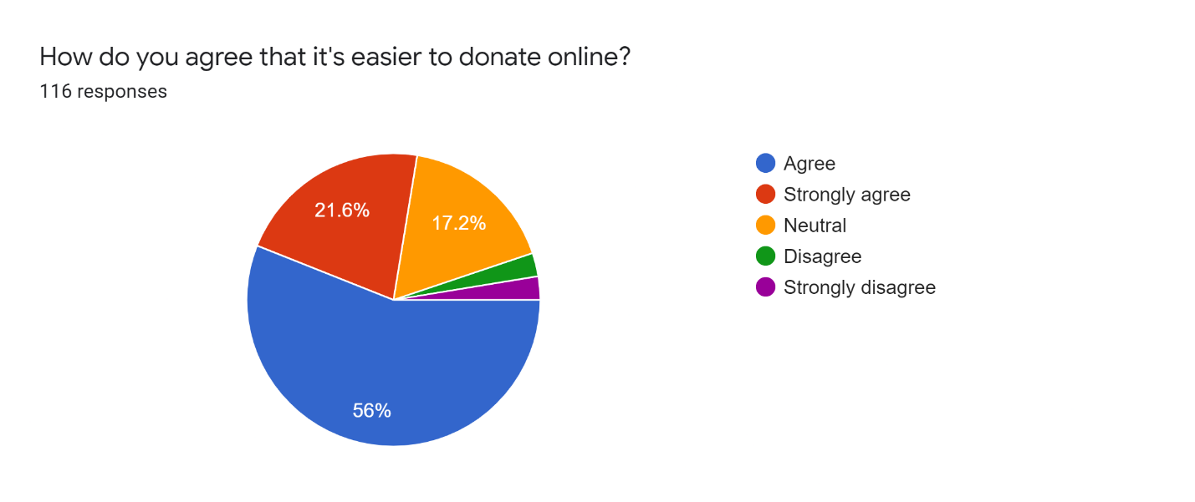

Fig 25: Is it easier to donate in online?

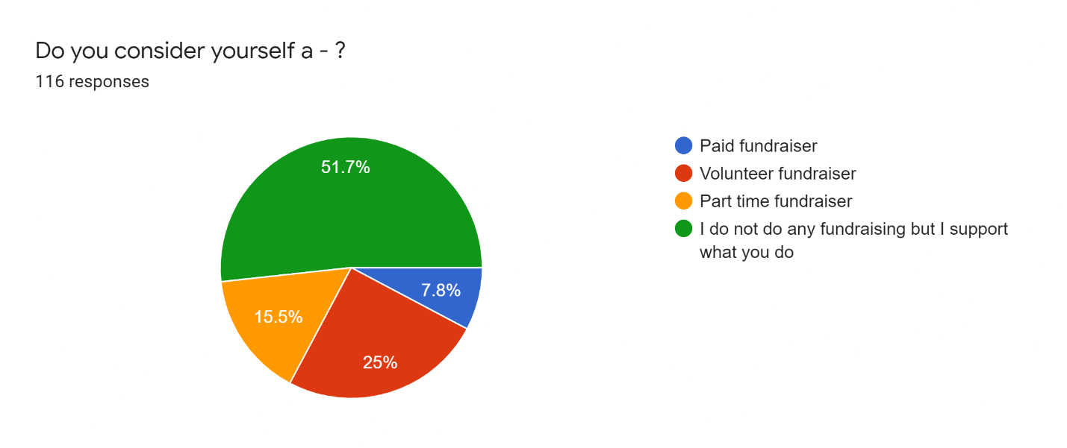

Fig 26: What type of fundraiser they are?

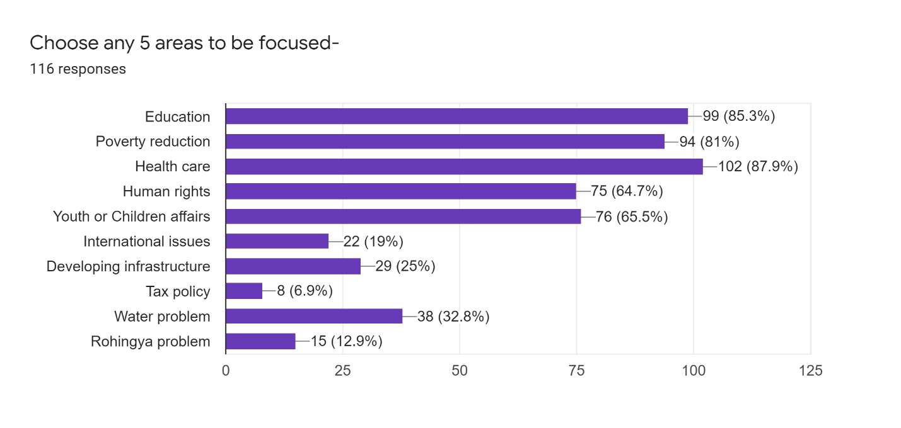

Fig 27: Any 5 areas they think to be focused